TourWin



Training Software to guide you to winning performance!
Peak Performance is reached only after careful planning, months of training and determination! TourWin™ is an invaluable tool to guide the athlete to their best performance for the biggest races.

Determination: The rewards for those who persevere far exceed the pain that must precede the victory.

Planning

TourWin ™ provides two key features for planning for success: the Peak schedule module and Calendar module.

Peak Schedule Module:
The peak schedule module allows the athlete to create unlimited training schedules up to 180 days in length. Unlimited peak schedules

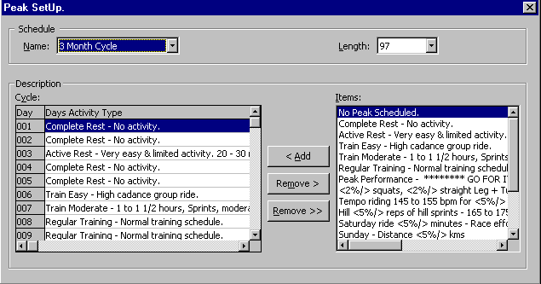

Features: Unlimited descriptions
TourWin™ supports percentage or amount increase on repeated schedules.
Unlimited item descriptions and peak schedules.

The schedule is then applied setup against the desired date range via the Calendar module: Supports 99 pages
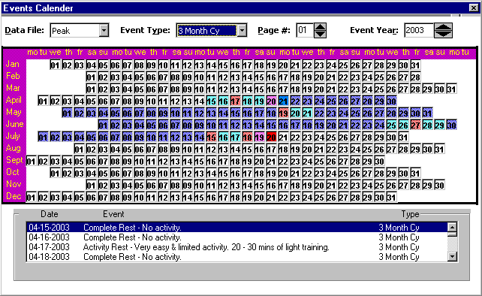
DAILY ACTIVITY AND MONITORING

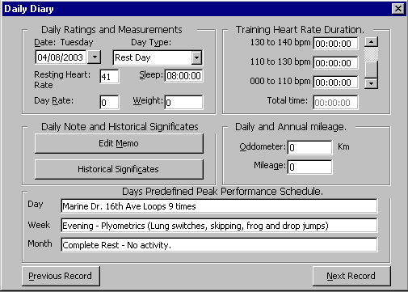

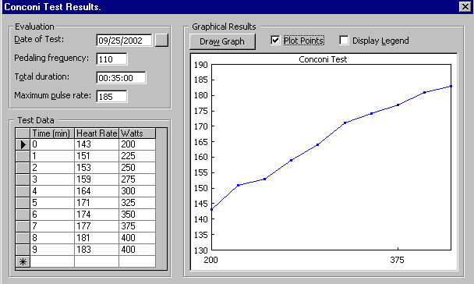

Reports:
X reports to review and monitor training.
